You are given a **0-indexed** m x n binary matrix grid.

A **0-indexed** m x n difference matrix diff is created with the following procedure:

* Let the number of ones in the ith row be onesRowi.
* Let the number of ones in the jth column be onesColj.
* Let the number of zeros in the ith row be zerosRowi.
* Let the number of zeros in the jth column be zerosColj.
* diff[i][j] = onesRowi + onesColj - zerosRowi - zerosColj

Return *the difference matrix* diff.

**Example 1:**

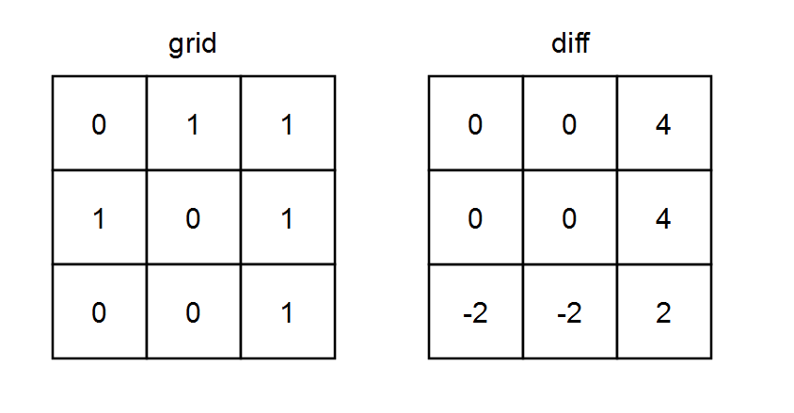

Input: grid = [[0,1,1],[1,0,1],[0,0,1]]  
Output: [[0,0,4],[0,0,4],[-2,-2,2]]  
Explanation:  
- diff[0][0] = onesRow0 + onesCol0 - zerosRow0 - zerosCol0 = 2 + 1 - 1 - 2 = 0   
- diff[0][1] = onesRow0 + onesCol1 - zerosRow0 - zerosCol1 = 2 + 1 - 1 - 2 = 0   
- diff[0][2] = onesRow0 + onesCol2 - zerosRow0 - zerosCol2 = 2 + 3 - 1 - 0 = 4   
- diff[1][0] = onesRow1 + onesCol0 - zerosRow1 - zerosCol0 = 2 + 1 - 1 - 2 = 0   
- diff[1][1] = onesRow1 + onesCol1 - zerosRow1 - zerosCol1 = 2 + 1 - 1 - 2 = 0   
- diff[1][2] = onesRow1 + onesCol2 - zerosRow1 - zerosCol2 = 2 + 3 - 1 - 0 = 4   
- diff[2][0] = onesRow2 + onesCol0 - zerosRow2 - zerosCol0 = 1 + 1 - 2 - 2 = -2  
- diff[2][1] = onesRow2 + onesCol1 - zerosRow2 - zerosCol1 = 1 + 1 - 2 - 2 = -2  
- diff[2][2] = onesRow2 + onesCol2 - zerosRow2 - zerosCol2 = 1 + 3 - 2 - 0 = 2

**Example 2:**

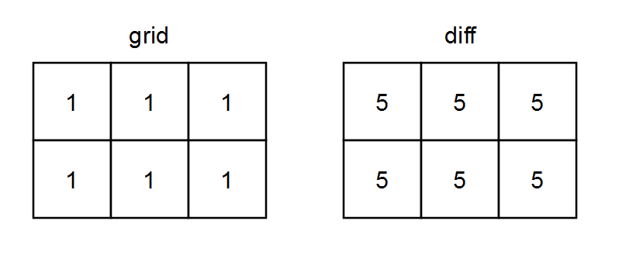

Input: grid = [[1,1,1],[1,1,1]]  
Output: [[5,5,5],[5,5,5]]  
Explanation:  
- diff[0][0] = onesRow0 + onesCol0 - zerosRow0 - zerosCol0 = 3 + 2 - 0 - 0 = 5  
- diff[0][1] = onesRow0 + onesCol1 - zerosRow0 - zerosCol1 = 3 + 2 - 0 - 0 = 5  
- diff[0][2] = onesRow0 + onesCol2 - zerosRow0 - zerosCol2 = 3 + 2 - 0 - 0 = 5  
- diff[1][0] = onesRow1 + onesCol0 - zerosRow1 - zerosCol0 = 3 + 2 - 0 - 0 = 5  
- diff[1][1] = onesRow1 + onesCol1 - zerosRow1 - zerosCol1 = 3 + 2 - 0 - 0 = 5  
- diff[1][2] = onesRow1 + onesCol2 - zerosRow1 - zerosCol2 = 3 + 2 - 0 - 0 = 5

**Constraints:**

* m == grid.length
* n == grid[i].length
* 1 <= m, n <= 105
* 1 <= m * n <= 105
* grid[i][j] is either 0 or 1.